The 2024 South West regional 10-19 years CROSS COUNTRY trials are to be held on Wednesday 15th May 2024

Districts/schools are to conduct trials to nominate suitable individuals to attend these trials.

NOMINATION WILL BE DISTRICT TEAMS OF MAXIMUM 6 RUNNERS PER AGE GROUP or IF NO DISTRICT (13 – 19 YRS ONLY) CARNIVAL HAS BEEN HELD, 4 RUNNERS PER AGE GROUP PER SCHOOL.

There are no qualifying times for students to participate at the South West trials.

Please note the following details:

DATE: Wednesday 15th May 2024

TIME: 9.00am

VENUE: Tara Racecourse
21 Showground Rd
Tara
AGES: 10 – 19 yrs – ie students born 2005-2014

WHAT TO BRING:
- Sunscreen
- Water
- First aid kit
- Food – a canteen will be operating
- Shade shelter / chairs
- Footwear must be worn to compete (It is recommended that students DO NOT wear spikes due to the changing surface of the course)

MEDICAL/PERMISSION FORMS:
All athletes must bring a completed SW trial permission form (RTPF) & Queensland School Sport consent form to the regional trial. NO FORM means the student will be unable to trial on the day.

SOUTH WEST TEAM:
At the conclusion of the trials a team may be selected of up to 6 students from each age, both male and female, to contest the state championships at Bald Hills, Brisbane from 12th – 14th July 2024

SELECTION PROCEDURES:
Qualifying times according to State Championship Guidelines.

MULTICLASS STUDENTS:
Multiclass students are eligible to be nominated for this regional trial. Multiclass athletes are to be nominated through meet manger as per the nomination process. Additionally, the multiclass entry list form (page 7) needs
to be completed and submitted with the meet manager nomination. Please only nominate students who have or an in the process of obtaining classification.

NOMINATIONS CLOSE:
- Wednesday 8th of May 2024 with:
- Tim Leadbetter
- RSSO – South West School Sport
- EMAIL: tim.leadbetter@qed.qld.gov.au

Nominations are to be emailed to the RSSO using Meet Manager.
Regional trial permission / consent form summary are to be emailed to the RSSO at the same time as the nomination.
The program files for MM are located on the regional trial page of the SWSS website.

Regional Trial Permission / Consent Form Summary

Please complete details below regarding South West School Sport Regional Trial Permission / Consent Form for district team members. This form must be returned at the same time as the nomination to the regional convenor. The nomination due date can be found in the regional trial bulletin.

REGIONAL TRIAL DETAILS

Event: |  | Venue: |  | Dates:

Media Release Section (Swimming, Cross Country & Track & Field only): all Forms received and approval given. Yes or No (if no, please provide details below)

Full consent to publish student information has NOT been received for the following team members
Student name | Playing number | Special requirements or instructions

Regional Trial Permission Form: all permission on form received and approval given. Yes or No (if no, please provide details below)

Parent, Student and or School Permission has NOT been received for the following team members
Student name |  | Playing number
Team Manager (name): |  |  |  | Total Number of Student Nominations:
Team Manager (signature): |  |  |  | Date:

Map

Course Description:

2km Loop
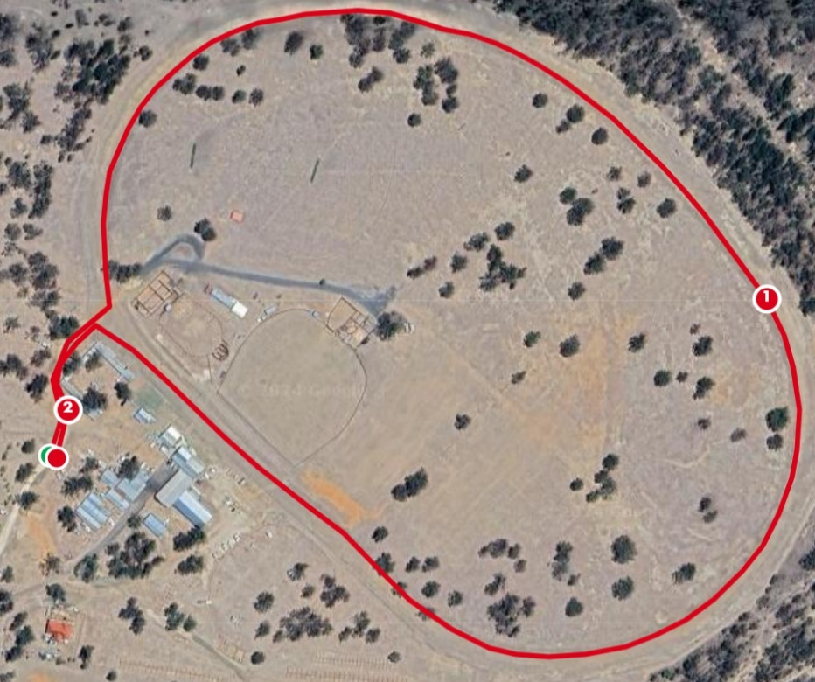

1km Route
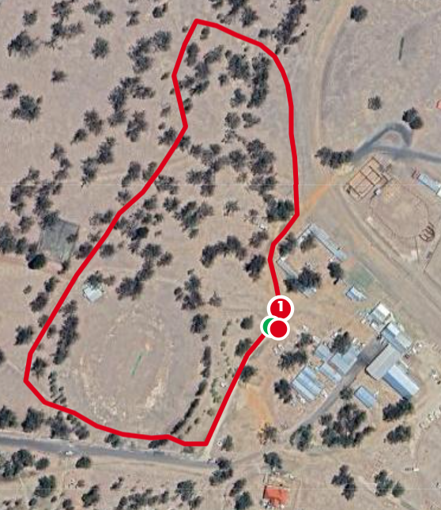

Event Time Table:
The event starting times are as follows:
NOTE: These times are a guide only and actual race times may vary. Competitors must be at the venue at least 1 hour prior to the scheduled time:
8:30am Officials and Team Managers meeting
9.00am Course Orientation
9.50am Race 1 – 10yrs Boys 2km
10.05am Race 2 – 10yrs Girls 2km
10.20am Race 3 – 14yrs Boys and 15yrs Boys 4km
10.20am Race 5 – 18/19yrs Boys 8km
11.10am Race 4 – 14, 15, 16 and 17yrs Girls 4km
11.40am Race 6 – 16 & 17yrs Boys &18/19yrs Girls 6km
12.20pm Race 7 – 11yrs Boys 3km
12.40pm Race 8 – 11yrs Girls 3km
1.00pm Race 9 – 12yrs Boys 3km
1.20pm Race 10 – 12yrs Girls 3km
1.40pm Race 11 – 13yrs Boys 3km
2.00pm Race 12 – 13yrs Girls 3km
2.20pm Clean-up/ Closure & Departure

Officials: For a successful carnival, helpers will be needed on the day for assistance in the running and officiating of events. Each district will be responsible for two (2) official positions on the day (can be shared). Names of teachers and parents to assist with the carnival MUST be provided on the attached form. District teams that do not list names of helpers WILL NOT be allowed to participate in the carnival.

Please return OFFICIAL’S SHEET, no later than Wednesday 8th May, to
Nicole McTigue
Ph: 46787333
Mobile : 0436930117
Email: nstat2@eq.edu.au

DISTRICT: _________________________________________________

All Districts are required to provide a minimum of 3 team officials to meet the minimum supervision requirements. 2 team officials will be required to assist with events to ensure the smooth running of the carnival.

Teachers/Parents attending Job

____________________________ Team Manager

____________________________ ________________________________
____________________________ ________________________________
____________________________ ________________________________

Return to Nicole McTigue
Email: nstat2@eq.edu.au
No later than Wednesday 8th May 2024

South West 10 – 19 Years Cross Country
Multi Class Athlete Entry List
District/School:
NAME | CLASSIFICATION | EVENT

This form to be returned to the Regional School Sport Officer with the Meet Manager/Team Manager nomination file by Wednesday 8th May 2024.

The following code of conduct highlights the level of expected behaviour of students, parents and spectators when participating in / attending Queensland School Sport (QSS) events. Consequences for not honouring this code of conduct are listed in the boxed sections. Please ensure that you have read and understand this code prior to participating in/attending QSS events. Further information is available by contacting South West School Sport, telephone (07) 4572 6513. Please be aware that ignorance of the contents of this Code will not be accepted as an excuse for any breach.

Expectations of student participants
As a team member
- Take responsibility for your own behaviour and performance.
- Compete by the competition conditions and rules.
- Follow all directions of team management/officials.
- Show respect and behave in a manner that respects the rights of all others (team members, opponents, officials, etc.) regardless of the medium of communication used, e.g. verbal, physical, digital media such as Twitter, Facebook, email and texts.
- Be a good sport. Encourage and support your team members.
- Wear the official team uniform at the times directed by team management/officials.
- Report in and out with team management/officials each day.
- As directed by team management/officials, stay in the designated team area and support other team members during times when not competing.
- Smoking, drinking of alcoholic beverages or the use of any illegal substances is strictly forbidden.
- Ensure that you have telephone numbers of team managers at all times.

Breach of the Code by Team Members
Team managers may deal immediately with any breaches of this code by imposing appropriate consequences, including not playing remaining fixtures, notification of parents, and being sent home at your parents’ expense. The Department, through South West School Sport (SWSS), is responsible for imposing any longer term consequences. Furthermore, SWSS may provide a report to your school and you may be subject to discipline in accordance with the Education (General Provisions) Act 2006 (EGPA). Students will be afforded natural justice in respect of breaches of this code and for any discipline under the EGPA.

Expectations of Parents and Spectators’

As a Parent or Guardian:
- Cooperate with the team officials to achieve the best outcomes for your child.
- Support team and event officials in maintaining a safe and respectful learning environment for all students.
- Maintain positive relationships with team officials regarding your child’s learning, well-being and behaviour.
- Encourage participation by your child.
- Provide a model of good sportsmanship for your child.
- Be courteous and constructive in your communication with players, team officials, game officials and sport administrators.
- Encourage honest effort, skilled performance and team loyalty.
- Do not interfere with the conduct of any events.
- Show respect and behave in a manner that respects the rights of all others regardless of the medium of communication used, e.g. verbal, physical, digital media such as Twitter, Facebook, email and texts.
- Adhere to the Department of Education’s policy of a smoke, alcohol and drug free environment.
As a Spectator:
- Demonstrate appropriate social behaviour.
- Remember children play for enjoyment. Don’t let your behaviour detract from their enjoyment.
- Let game officials conduct events without interference.
- Support skilled performances and team play.
- Show respect and behave in a manner that respects the rights of all others regardless of the medium of communication used, e.g. verbal, physical, digital media such as Twitter, Facebook, email and texts.
- Adhere to the Department of Education’s policy of a smoke, alcohol and drug free environment.

Breach of the Code by Parents and Spectators
Team managers and event organisers may deal immediately with any breaches of this code by warning offenders about their conduct, asking offenders to leave venues, and calling police to intervene where necessary. The Department, through South West School Sport (SWSS), is responsible for imposing any longer term consequences such as written warnings, or barring attendance at future events for a period or indefinitely.
Parents and spectators should note that it is an offence to insult (meaning "to treat insolently or with contemptuous rudeness, to abuse") an officer of a state educational institution – Section 333 Wilful Disturbance, of the Education (General Provisions) Act 2006 (EGPA). Parents and spectators will be afforded natural justice in respect of breaches of this code and for any discipline under the EGPA.

